

Mohammad Ali Jinnah University

Chartered by Government of Sindh - Recognized by HEC

**Lab Task 7**

**Name:** Muhamad Fahad

**Id:** FA19-BSSE-0014

**Subject:** Data Structures and Algorithms Lab (CS 2511)

**Lab Title:** Queue

**Section:** AM

**Teacher:** MUHAMMAD MUBASHIR KHAN

**Date:** Friday, December 11, 2020

**Q1) Create your own queue class with following methods:**

**--> Enqueue**

**--> Dequeue**

**--> Get_Front**

**--> Get_Rear**

**Code:**

import java.util.Arrays;  
import java.util.Scanner;  
  
public class Queue {  
 public int SIZE,front, rear;  
 public int[] items;  
  
 Queue(int Size) {  
 this.SIZE = Size;  
 this.front = this.rear = -1;  
 this.items = new int[SIZE];  
 }  
  
 String Get_Front(){  
 return this.front+" = "+this.items[front];  
 }  
  
 String Get_Rear(){  
 return this.rear+" = "+this.items[rear];  
 }  
  
 boolean isFull() {  
 if (front == 0 && rear == SIZE - 1) {  
 return true;  
 }  
 return false;  
 }  
  
 // check if the queue is empty  
 boolean isEmpty() {  
 if (front == -1)  
 return true;  
 else  
 return false;  
 }  
  
 // insert elements to the queue  
 void enQueue(int element) {  
 // if queue is full  
 if (isFull()) {  
 System.*out*.println("Queue Is full");  
 }  
 else {  
 if (front == -1) {  
 front = 0;  
 }  
  
 rear++;  
 items[rear] = element;  
 }  
 }  
  
 // delete element from the queue  
 int deQueue() {  
 int element;  
  
 if (isEmpty()) {  
 System.*out*.println("Queue Is Empty");  
 return (-1);  
 }  
 else {  
 element = items[front];  
  
 if (front >= rear) {  
 front = -1;  
 rear = -1;  
 items = new int[this.SIZE];  
 }  
 else {  
 front++;  
 items = Arrays.*copyOfRange*(items, 1, rear+1);  
 items = Arrays.*copyOf*(items, this.SIZE);  
 rear--;  
 }  
  
 return (element);  
 }  
 }  
  
  
 String display() {  
 String temp = "{";  
 if (isEmpty()){  
 temp += " }";  
 return temp;  
 }  
  
 for (int i = 0; i <= rear; i++) {  
 temp += items[i]+",";  
 }  
 temp += "\b}";  
 return temp;  
 }  
  
 public static void main(String[] args) {  
 System.*out*.println("Q1) Create your own queue class with following methods: (Enqueue, Dequeue, Get_Front, Get_Rear");  
 Queue q = new Queue(8);  
  
 for(int i = 1; i < 9; i ++) {  
 q.enQueue(i);  
 }  
  
 System.*out*.println("Queue"+q.display());  
 System.*out*.println("Dequeue: "+q.deQueue());  
 q.enQueue(9);  
 System.*out*.println("Enqueue:"+q.display());  
 System.*out*.println("Get_Front: "+q.Get_Front()+", Get_Rear: "+q.Get_Rear());  
 }

**Output:**

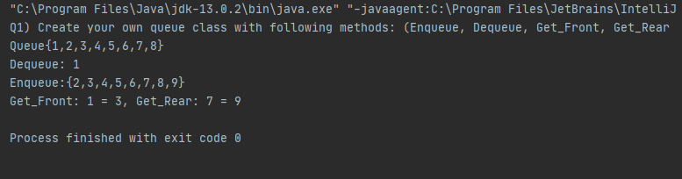

**Q2) Delete User given number from a queue.**

**Code:**

class Queue2 extends Queue{  
  
 Scanner scan = new Scanner(System.*in*);  
 Queue2(int size){  
 super(size);  
 }  
  
 int Delete(int Element){  
 boolean flag = false;  
 if (isEmpty()){  
 System.*out*.println("Queue Is Empty");  
 return (-1);  
 }  
 int length = rear-front;  
 for (int i = length; i > 0; i--) {  
 if(items[i] == Element){  
 items[i] = items[i-1];  
 items[i-1] = Element;  
 }  
 }  
  
 if(flag){  
 System.*out*.print("Number not found in the Queue (Error: ");  
 return (-1);  
 }  
  
 return this.deQueue();  
 }  
  
 void Input(){  
 System.*out*.print("Enter the Complete Array(separate with ,): ");  
 String input[] = (scan.next()).split(",");  
  
 for (int i = 0; i < input.length; i++)  
 this.enQueue(Integer.*parseInt*(input[i]));  
 }  
  
 public static void main(String[] args) {  
 Queue2 obj = new Queue2(8);  
 obj.Input();  
 System.*out*.println(obj.display());  
 System.*out*.print("Enter the number to delete from the queue: ");  
 int element = obj.scan.nextInt();  
 System.*out*.println("Delete: "+obj.Delete(element));  
 System.*out*.println(obj.display());  
  
 }

**Output:**

